MTCS 103 (P) – Parallel Programming
Labwork 10 Report
By
Sai Suraj - 21560

openmp:

Size N | Threads
Size N | 8 | 7 | 6 | 5 | 4 | 3 | 2 | 1
10 | 0.000800171 | 0.000648756 | 0.000587909 | 0.000591655 | 0.00024817 | 0.000187323 | 7.04E-05 | 1.7E-05
10^2 | 0.00115145 | 0.00225564 | 0.00127341 | 0.000760026 | 0.000194581 | 0.000191366 | 0.000163835 | 5.51E-06
10^3 | 0.00322252 | 0.00234567 | 0.00283807 | 0.00247096 | 0.000267389 | 0.000133393 | 0.00015012 | 2.71E-05
10^4 | 0.0069195 | 0.0060702 | 0.00475133 | 0.00682459 | 0.00049415 | 0.000343256 | 0.000356968 | 0.000175783
10^5 | 0.0102712 | 0.00842068 | 0.0163619 | 0.0158785 | 0.000634581 | 0.00062327 | 0.00134608 | 0.00142475
10^6 | 0.0277936 | 0.0422995 | 0.0253388 | 0.01881 | 0.00443 | 0.00495093 | 0.00650594 | 0.00670461
10^7 | 0.112506 | 0.110147 | 0.109883 | 0.0995067 | 0.062071 | 0.0599028 | 0.0730183 | 0.0950249
10^8 | 1.36858 | 1.24266 | 1.3255 | 1.1766 | 1.18331 | 1.1205 | 1.24554 | 1.40919
10^9 | 15.4883 | 16.7792 | 17.2666 | 16.4172 | 17.0177 | 17.0516 | 16.0223 | 20.181
10^10 | 25.1363 | 25.5857 | 23.4515 | 23.2912 | 22.3657 | 22.4693 | 23.2632 | 26.9724

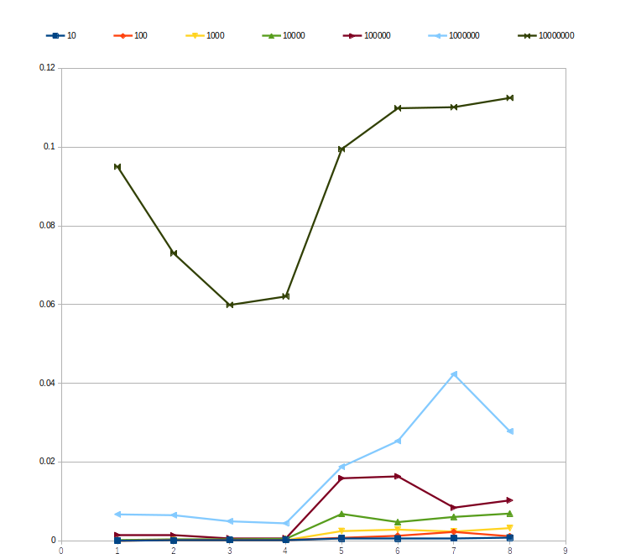

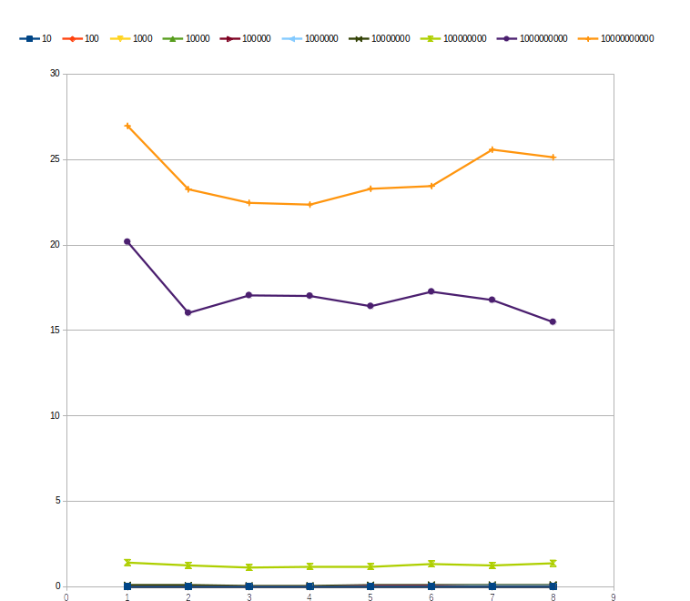
MPI:

Size N | Execution Time
10 | 8.4E-05
10^2 | 2.3E-05
10^3 | 4.1E-05
10^4 | 0.000167
10^5 | 0.001726
10^6 | 0.018809
10^7 | 0.256097
10^8 | 3.043345
10^9 | 36.900051
10^10 | 49.123913

